The Islamia University of Bahawalpur
Department of Information Technology



SOFTWARE REQUIREMENTS SPECIFICATION
(SRS DOCUMENT)
for

Car Wash Appointment

Version 1.0

By
Tania Ajmal
F22BINFT1E02057
Fall 2022 – 2026

Supervisor
Mam Sara Farid

Table of Contents

Revision History 1
Application Evaluation History 2
Introduction 3
Purpose 3
Scope 3
Overall description 3
Product perspective 3
Operating environment 3
Design and implementation constraints 3
Requirement identifying technique 4
Use case diagram 4
Use case description 4
Functional Requirements 6
Functional Requirement X 6
Non Functional Requirements 7
Usability 7
Performance 8
References 8

Revision History

Name | Date | Reason for changes | Version

Application Evaluation History

The Application Evaluation History feature of our Car Wash Appointment app enables users to track their car wash appointments and view their appointment history. With this feature, users can easily book their car wash appointments at their preferred time and date, and receive reminders and updates about their appointments. Our app provides a seamless and convenient experience for users to manage their car wash appointments, and also allows them to rate and review the services provided by the shop. Key features of our app include user registration, shop information, car wash services, appointment scheduling, notification system, and rating and review | Action Taken

Supervised by
Mam Sara Farid

Signature

Introduction
This Software Requirements Specification (SRS) document outlines the requirements for the Car Wash Appointment mobile application. The purpose of this document is to provide a detailed description of the application's functionality, user interface, and performance requirements.

Purpose

The purpose of this document is to specify the requirements for the Car Wash Appointment mobile application. This application is designed to provide a convenient and user-friendly way for car owners to book and manage their car wash appointments.

Scope

The Car Wash Appointment mobile application is a software system designed to provide a convenient and user-friendly way for car owners to book and manage their car wash appointments. The application will enable users to book appointments, view and manage their appointment schedules, receive reminders and notifications, and rate and review the car wash services.

Overall description

Product perspective

The Car Wash Appointment mobile application is a new product designed to provide a convenient and user-friendly way for car owners to book and manage their car wash appointments. This application is not a replacement for an existing application, but rather a new solution to address the growing demand for online car wash appointment booking.

The application is designed to be a standalone product, but it may also be integrated with existing car wash management systems in the future. The application will be developed using modern technologies and will be designed to be scalable and flexible to meet the changing needs of the car wash industry.

Operating environment

The Car Wash Appointment mobile application will operate in the following environment:

- Hardware Platform: The application will be developed for Android-based device for smartphones.
- Operating Systems and Versions: The application will be compatible with the following Android versions:
- Android 8.0 (Oreo) and above
- Geographical Locations: The application will be accessible to users in all geographical locations, with the ability to book appointments at car wash shops in their local area.
- Organizations that Host Related Databases, Servers, and Websites: The application will be hosted on a secure server, with data stored in a secure database. The application will also integrate with third-party payment gateways and car wash shop management systems.

Specific Operating Environment Requirements:

- OE-1: The application shall operate correctly on devices with screen sizes ranging from 4 inches to 12 inches.
- OE-2: The application shall be compatible with the following Android architectures: ARM, ARM64, x86, and x86_64.
- OE-3: The application shall be able to operate in both online and offline modes, with the ability to sync data when the device is connected to the internet.

Design and implementation constraints

The development of the Car Wash Appointment mobile application will be subject to the following design and implementation constraints:
1. Programming Language: The application will be developed using Java programming language, as it is the primary language supported by Android Studio.
2. Development Framework: The application will be developed using Android Studio, as it is the official integrated development environment (IDE) for Android app development.
3. Database Management System: The application will use a SQLite database management system, as it is a lightweight and efficient database solution for mobile applications.
4. Third-Party Libraries: The application will use third-party libraries, such as Google Maps and PayPal, to provide additional functionality and services.
5. Security: The application will implement security measures, such as encryption and secure authentication, to protect user data and prevent unauthorized access.
6. Compatibility: The application will be designed to be for Android devices smartphones
7. Performance: The application will be optimized for performance, with a focus on fast loading times, smooth animations, and efficient data processing.

Requirement identifying technique

The requirements for the Car Wash Appointment mobile application will be identified using the Use Case technique. This technique is effective for interactive end-user applications, such as the Car Wash Appointment app, which requires user input and interaction.

Use case diagram

The following use case diagram illustrates the main actors and use cases for the Car Wash Appointment app:

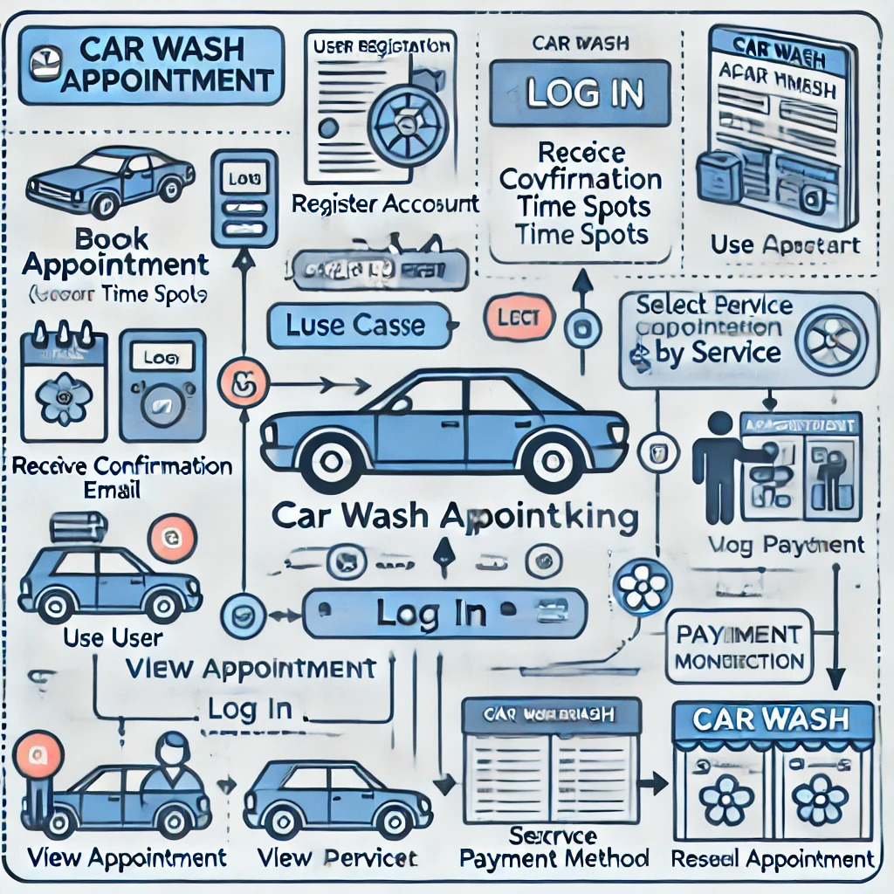

- Actor: User- Actor: Car Wash Shop
- Use Case : - View Car Wash Prices
- Use Case: Book Appointment
- Use Case: View Appointment Schedule
- Use Case: Cancel Appointment
- Use Case: Rate and Review Car Wash Shop

Use case description

The following use case descriptions provide a detailed explanation of each use case:

- Book Appointment: The user selects a car wash shop and a time slot to book an appointment. The app sends a confirmation notification to the user and updates the car wash shop's schedule.
View Car Wash Prices: The user views the prices of different car wash services, including interior and exterior washes, waxing, and detailing. The app displays the prices for both in-shop and mobile car wash services.

- View Appointment Schedule: The user views their upcoming appointments and can cancel or reschedule them.
- Cancel Appointment: The user cancels an upcoming appointment, and the app updates the car wash shop's schedule.
- Rate and Review Car Wash Shop: The user rates and reviews the car wash shop after completing an appointment.

Table 5 Show the detail use case template
Use Case ID: | UC-1
Use Case Name: | Book a Car Wash Appointment
Actors: | Car Owner, Secondary Actors: Car Wash Shop, Payment Gateway
Description: | A car owner accesses the Car Wash Appointment app, selects a car wash shop, chooses a time slot, and books an appointment for a car wash service.

Trigger: | A car owner indicates that they want to book a car wash appointment
Preconditions: | PRE-1. Car owner is registered with the app.  PRE-2. Car owner has a valid payment method.
Postconditions: | POST-1. Appointment is booked and confirmed.  POST-2. Car wash shop receives notification of the appointment.  POST-3. Payment is processed.
Normal Flow: | 1. Car owner selects a car wash shop.  2. App displays available time slots for the selected shop.  3. Car owner chooses a time slot.  4. App displays car wash services and prices.  5. Car owner selects a car wash service.  6. App displays payment options:  - Cash on delivery (COD)  - Online payment (via JazzCash,EasyPasa)  7. Car owner selects a payment method:  - If COD, app confirms appointment and displays payment instructions.  - If online payment, app redirects to payment gateway for secure payment processing.  8. App processes payment (if online payment).  9. App confirms appointment and sends confirmation notification to car owner.
Alternative Flows: [Alternative Flow 1 – Not in Network] | 1. Car owner cancels appointment.  1. App displays cancellation confirmation.  2. App updates appointment status.  1.2. Car owner modifies appointment.  1. App displays modification options.  2. Car owner selects new time slot or car wash service.  3. App updates appointment.
Exceptions: | E1. Selected time slot is not available.  1. App displays error message.  2. App offers alternative time slots.  1.0. E2. Payment processing fails.  1. App displays error message.  2. App offers alternative payment options.
Business Rules | 1. Appointment time slots are 30 minutes.  2. Car wash services can be booked up to 24 hours in advance.
Assumptions: | 1. Assume that 80% of car owners will book appointments online.  2. Assume that 20% of car owners will cancel or modify their appointments.

Functional Requirements
The following functional requirements are organized by feature:
User Registration

1: The system shall allow users to register for an account using their email address and password.
2: The system shall send a confirmation email to the user's registered email address.
3: The system shall allow users to log in to their account using their email address and password.

Car Wash Appointment Booking

1: The system shall allow users to book a car wash appointment for a specific date and time.
2: The system shall display available time slots for the selected car wash shop.
3: The system shall allow users to select a car wash service and payment method.

Car Prices
1: The system shall display car wash prices for different car types (e.g. sedan, SUV, truck).
2: The system shall display prices for different car wash services (e.g. basic, deluxe, premium).
3: The system shall allow users to select a car type and car wash service to view the corresponding price.

Payment Processing

1: The system shall process payments for car wash appointments using a secure payment gateway.
2: The system shall display payment confirmation and receipt to the user.

Appointment Management

1: The system shall allow users to view and manage their upcoming appointments.
2: The system shall allow users to cancel or reschedule their appointments.

Functional Requirement X

Functional Requirement ID: FR-1.1
Feature: User Registration
Description: The system shall allow users to register for an account using their email address and password.
Rationale: To provide a secure and personalized experience for users.
Source: User requirements gathering
Dependencies: None

Functional Requirement ID: FR-1.2
Feature: User Registration
Description: The system shall send a confirmation email to the user's registered email address.
Rationale: To verify the user's email address and ensure account security.
Source: User requirements gathering
Dependencies: FR-1.1

Functional Requirement ID: FR-2.1
Feature: Car Wash Appointment Booking
Description: The system shall allow users to book a car wash appointment for a specific date and time.
Rationale: To provide a convenient and efficient way for users to book car wash appointments.
Source: User requirements gathering
Dependencies: FR-1.1, FR-1.2

Functional Requirement ID: FR-3.1
Feature: Car Prices
Description: The system shall display car wash prices for different car types (e.g. sedan, SUV, truck).
Rationale: To provide users with accurate and up-to-date pricing information.
Source: User requirements gathering
Dependencies: None

Error Handling:

- If the user enters an invalid email address, the system shall display an error message and prompt the user to re-enter their email address.
- If the user enters an invalid password, the system shall display an error message and prompt the user to re-enter their password.
- If the system encounters an error while processing a car wash appointment booking, the system shall display an error message and prompt the user to try again.

Non-Functional Requirements
Performance: The system shall respond to user requests within 2 seconds. The response time shall be measured using a stopwatch. The priority of this requirement is High.
Security: The system shall encrypt all sensitive user data, including payment information. The encryption algorithm shall be AES-256. The priority of this requirement is High.
Usability: The system shall provide an intuitive user interface that allows users to easily book and manage their car wash appointments. The user satisfaction rating shall be measured using a survey. The priority of this requirement is Medium.
Maintainability: The system shall allow administrators to update software components without downtime. The update time shall be measured using a stopwatch. The priority of this requirement is Medium.
- Scalability: The system shall support up to 1000 concurrent users. The concurrent users shall be measured using a load testing tool. The priority of this requirement is High.
Availability: The system shall be available 24/7, with a maximum downtime of 1 hour per month. The uptime shall be measured using a monitoring tool. The priority of this requirement is High.
Data Integrity: The system shall ensure that all user data, including appointment schedules and payment information, is accurate and up-to-date. The data accuracy shall be measured using a data validation tool. The priority of this requirement is High.
Accessibility: The system shall be accessible on multiple devices and platforms, including desktop, mobile, and tablet devices. The device compatibility shall be measured using a testing tool. The priority of this requirement is Medium.

Usability

1: The system shall allow users to book a car wash appointment with a minimum of 3 interactions.
2: The system shall provide a clear and concise user interface that allows users to easily navigate and find the information they need.
3: The system shall allow users to view and manage their appointment schedules with a single interaction.
4: The system shall provide error messages and warnings that are clear, concise, and helpful in resolving the issue.
5: The system shall allow users to cancel or reschedule their appointments with a minimum of 2 interactions.
6: The system shall provide a search function that allows users to quickly find car wash services and locations.
7: The system shall allow users to view and manage their payment information with a single interaction.
8: The system shall provide a help function that provides users with clear and concise instructions on how to use the system.

Performance

1. Appointment booking page load time: 2 seconds
2. Payment transaction processing time: 3 seconds
3. Search results return time: 1 second
4. Appointment confirmation email sending time: 1 minute
5. User login attempt processing time: 1 second
6. Appointment schedule update time: real-time (less than 1 second)
7. Payment processing error resolution time: 2 minutes

References
1. User Interface Style Guide: "Car Wash Appointment App UI Style Guide" (Version 1.0)
2. System Requirements Specification: "Car Wash Appointment App System Requirements" (Version 1.0)
3. Interface Specification: "Car Wash Appointment App API Interface Specification" (Version 1.0)
4. Payment Gateway Integration Guide: "Payment Gateway Integration Guide for Car Wash Appointment App" (Version 1.0)
5. Security Standards: "Car Wash Appointment App Security Standards" (Version 1.0)

